Practice Question 1 – WACC (with solution)
Question 1. Edna Recording Studios, Inc., reported earnings available to common stock of $4,200,000 last year. From those earnings, the company paid a dividend of $1.26 on each of its 1,000,000 common shares outstanding. The capital structure of the company includes 40% debt, 10% preferred stock, and 50% common stock. It is taxed at a rate of 40%.
- If the market price of the common stock is $40 and dividends are expected to grow at a rate of 6% per year for the foreseeable future, what is the company’s cost of retained earnings financing?
- If under-pricing and flotation costs on new shares of common stock amount to $7.00 per share, what is the company’s cost of new common stock financing?
- The company can issue $2.00 dividend preferred stock for a market price of $25.00 per share. Flotation costs would amount to $3.00 per share. What is the cost of preferred stock financing?
- The company can issue $1,000-par-value, 10% coupon, 5-year bonds that can be sold for $1,200 each. Flotation costs would amount to $25.00 per bond. Use the estimation formula to figure out the approximate cost of debt financing.
- What is the WACC?
Solution
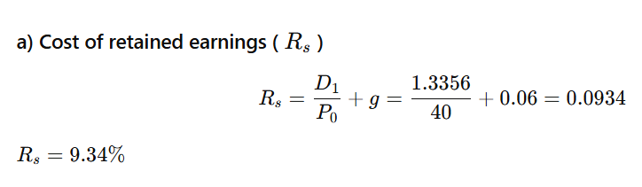
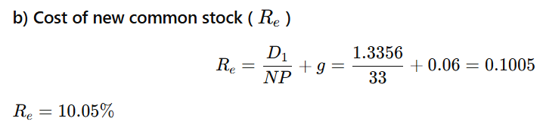
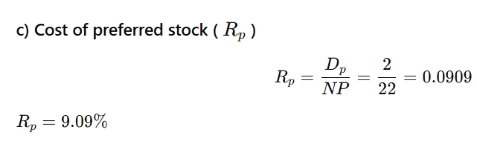
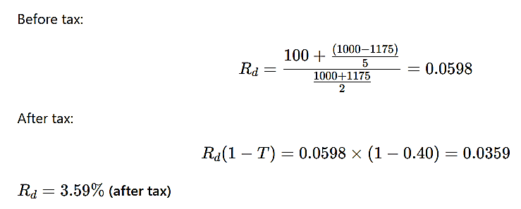

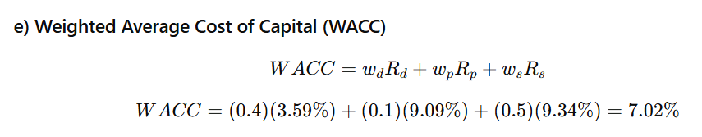

Question 2 Lang Enterprises is interested in measuring its overall cost of capital. The current investigation has gathered the following data. The firm is in the 40% tax bracket.
Debt: The firm can raise debt by selling $1,000-par-value, 8% coupon interest rate, 20-year bonds on which annual interest payments will be made. To sell the issue, an average discount of $30 per bond would have to be given. The firm also must pay the flotation costs of $30 per bond.
Preferred stock: The firm can sell 8% preferred stock at its $95-per-share par value. The cost of issuing and selling the preferred stock is expected to be $5 per share. Preferred stock can be sold under these terms.
Common stock: Lang Enterprises is interested in measuring its overall cost of capital. Current investigation has gathered the following data. The firm is in the 40% tax bracket.
The firm’s common stock is currently selling for $90 per share. The firm expects to pay cash dividends of $7 per share next year. The firm’s dividends have been growing at an annual rate of 6%, and this growth is expected to continue into the future. The stock must be underpriced by $7 per share, and flotation costs are expected to amount to $5 per share. The firm can sell new common stock under these terms.
Required:
- Calculate the after-tax cost of debt.
- Calculate the cost of preferred stock.
- Calculate the cost of common stock.
- Calculate the firm’s weighted average cost of capital if the capital structure comprises as under:
Ordinary Share Capital $ 500,000
Long Term Debt $ 300,000
Preferred Stock $ 200,000
Solution:
